1)
UPDATE blinkit_data
SET `Item Fat Content` =
CASE
WHEN `Item Fat Content` IN ('LF', 'low fat') THEN 'Low Fat'
WHEN `Item Fat Content` = 'reg' THEN 'Regular'
ELSE `Item Fat Content`
END;

SELECT `Item Fat Content`
FROM blinkit_data
LIMIT 5 ;
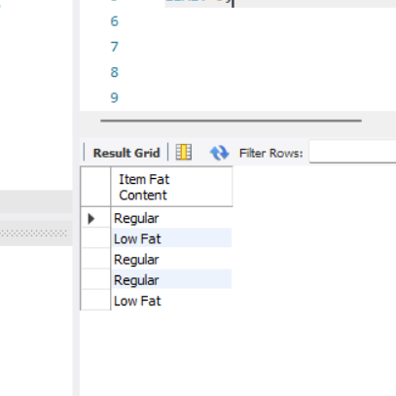

- The overall revenue generated from all items sold.

SELECT CAST(SUM(Sales)/100000 AS DECIMAL(10,2)) AS Total_Sales_in_Millions
from blinkit_data;
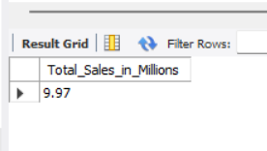

- The average revenue per sale

SELECT CAST(AVG(Sales) AS DECIMAL(10,2)) AS Average_Sales
FROM blinkit_data;
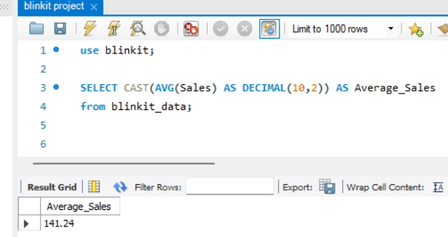

4)The total count of different items sold.

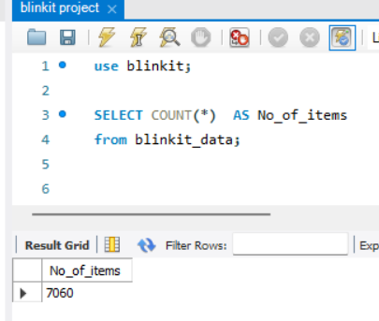

5)The average customer rating for items sold.
SELECT CAST(AVG(Rating) AS DECIMAL(10,2)) AS Average_ratings
from blinkit_data;
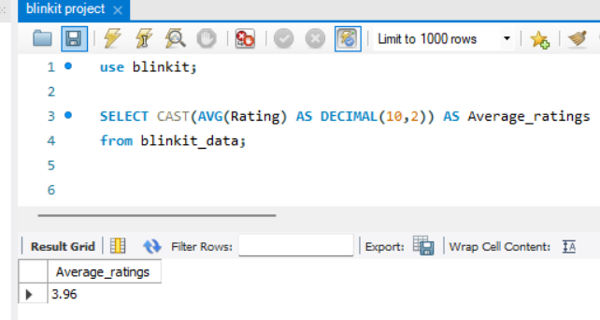

Granular Requirements

- Total Sales by Fat content
SELECT
`Item Fat Content`,
sum(Sales) as total_sales,
avg(Sales) as average_sales,
count(*) as number_of_items,
avg(Rating) as average_ratings
FROM blinkit_data
GROUP BY `Item Fat Content`;

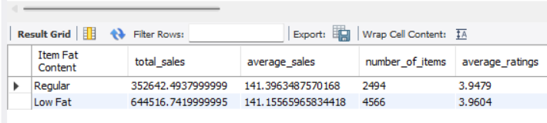

- Total sales by Item type
SELECT
`Item Type`,
sum(Sales) as total_sales,
avg(Sales) as average_sales,
count(*) as number_of_items,
avg(Rating) as average_ratings
FROM blinkit_data
GROUP BY `Item Type`;
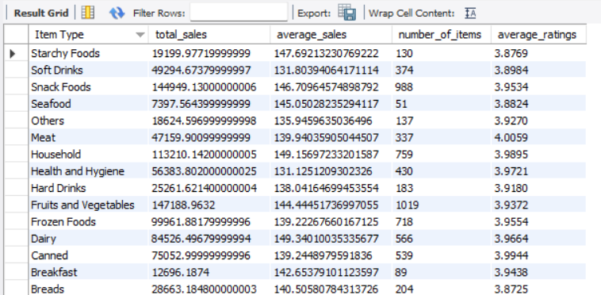

- Fat content by outlet for total sales
SELECT
`Outlet Identifier`,
`Item Fat Content`,
SUM(Sales) AS total_sales,
AVG(Sales) AS average_sales,
COUNT(*) AS number_of_items,
AVG(Rating) AS average_rating
FROM blinkit_data
GROUP BY
`Outlet Identifier`,
`Item Fat Content`
ORDER BY
`Outlet Identifier`,
`Item Fat Content`;

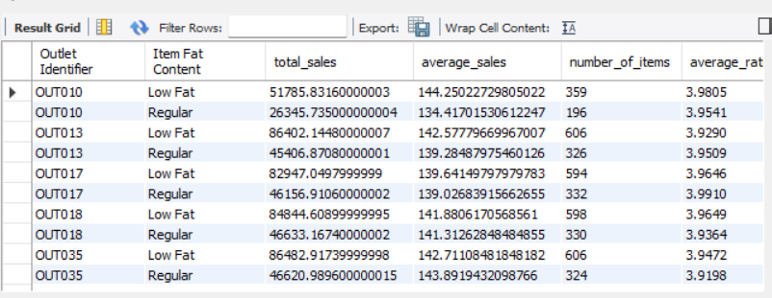

- Total Sales by outlet establishment
SELECT
`Outlet Establishment Year`,
sum(Sales) as total_sales,
avg(Sales) as average_sales,
count(*) as number_of_items,
avg(Rating) as average_ratings
FROM blinkit_data
GROUP BY `Outlet Establishment Year`
ORDER BY `Outlet Establishment Year`;
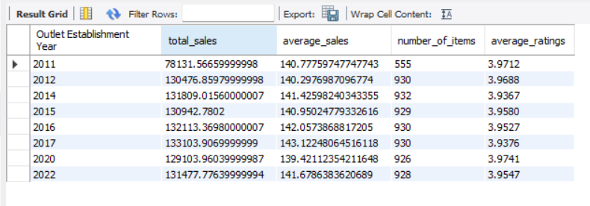

Chart ‘s requirements
- Percentage of Sales by Outlet Size
SELECT
`Outlet Size`,
CAST(SUM(Sales) AS DECIMAL(10,2)) AS Total_Sales,
AVG(Sales) AS average_sales,
COUNT(*) AS number_of_items,
AVG(Rating) AS average_ratings,
CAST( SUM(Sales) * 100.0 / SUM(SUM(Sales)) OVER() AS DECIMAL(10,2) ) AS sales_percentage
FROM blinkit_data
GROUP BY `Outlet Size`
ORDER BY `Outlet Size`;
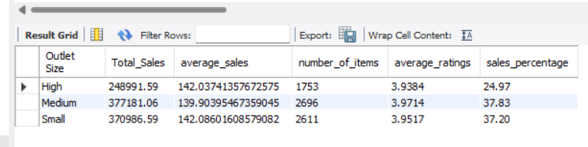
- Sales by Outlet Location
SELECT
`Outlet Location`,
SUM(Sales) AS total_sales,
AVG(Sales) AS average_sales,
COUNT(*) AS number_of_items,
AVG(Rating) AS average_ratings
FROM blinkit_data
GROUP BY `Outlet Location`
ORDER BY `Outlet Location`;
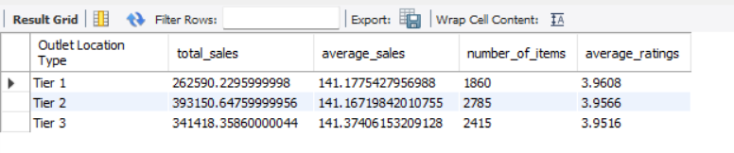
- All metrics by outlet type
SELECT
`Outlet Type`,
SUM(Sales) AS total_sales,
AVG(Sales) AS average_sales,
COUNT(*) AS number_of_items,
AVG(Rating) AS average_ratings
FROM blinkit_data
GROUP BY `Outlet Type`
ORDER BY `Outlet Type`;


